Landon Leigh

Activity 3

1. We need DFD because a neat and clear one can show a good amount of the system requirements graphically and allow for a much easier understanding of it.

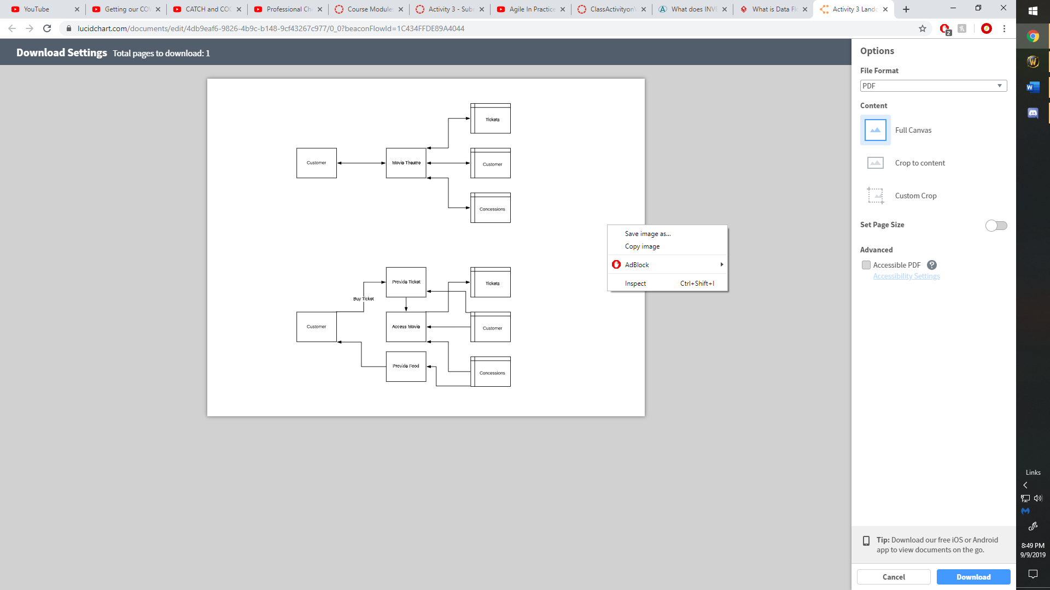

1. The structure of user stories in the video is a story card. The story cards structure is: As a… I need… so that… Examples of user stories are: As a customer, I need to be able to navigate an online stories inventory so that I can easily order the items that I want. As a teacher, I need a program that tracks the participation of my students so that I can grade their participation correctly. As a business owner, I need a full list of my employees so that I can better get to know them.
2. INVEST stands for: Independent, Negotiable, Valuable, Estimable, Small, Testable. If one of these fails, the team may want to reword or even rewrite the story.
3. “Our highest priority is to satisfy the customer through early and continuous delivery of valuable software.” This describes that agile is used to work with the focus of allowing the customer to have often and quick updates with software so that the customer’s needs are consistently met.
4. User stories have 3 parts. These parts are the card, which is a writer description of the story for planning purposes; the conversation, which is where you can get more information on the story and details of conversations; and confirmation, which is where you will convey the tests that will be carried out to confirm if the story is working as needed.
5. You need product backlog because it is basically a wish list of what would make the product great. It allows the user to tell what they want in a product.
6. Release backlog is a collection of the prioritized set of user stories and the rough estimate of the total work that will be involved to complete the entire release.
7. Sprints are short milestones that allow a team to plan out and tackle a chunk of the project and get it to a ship ready state in a manageable amount of time. This is used so that by the end of each sprint you have a fully tested product that is ship ready.
8. The burndown chart is the number one reason for scrums popularity. It provides a day by day measure of the amount of work that remains in a certain sprint. It allows you to calculate the estimated completion date. Thinking back to a project that I did in my history class last semester on hacking, I could have used the burndown chart to tell me when estimated completion date was so that my group could have realized and worked a little harder over the entire period rather than working very hard at the end.